James Eakins

Assignment 2

2019/10/27

Design Plan for “The Place of Wizardly Needs” (PWN)

What do they do?

The Place of Wizardly Needs (PWN) is a company that specializes in every form of magic known. This is shown with the mall-like structure of the building, with many sections and different magic based things to do.

What is the site for?

The site is meant for many things, one is to sign-up for the training programs done in the Tower Section. The second is for people who want to buy magical items online, and the last is to advertise the museum and company itself. Although the site has a lot of things to do I think it would be fine if the site is sectioned off neatly.

List of Pages:

Home:

Has the sign-up sheet for the classes, a brief mention of the museum and an about us section.

Museum:

Shows some of the more popular magic items from the museum to make people interested to come to the museum for real.

Shop:

Allows users of the site to browse and buy magical items and equipment. Also will have an “Immediate Shipping” option which teleports items to you.

Courses:

Probably the most difficult part of the site is the Tower. This section shows every available class to take and their requirements (such as age). The difficulty comes for how it will display them. Each class will have their own section representing the level of difficulty and height of the Tower. Every floor will have a different color to it to appeal to the age range. For example the beginning will be the normal site because it’s where everyone begins, then the middle area is very dark to shown the difficulty and because by the time you get there the recommended age would be around teen. Then the final levels will get lighter to signify enlightenment and to appeal to the age range, which at this point would be pretty old.

Training:

This page is for our training rooms where you can practice magic in your own protected room. A membership is required to enter but you get a free one when you enlist in a course.

Contact:

The final page is customer support for any issues such as not receiving membership and what-not.

Intended Audience:

The target audience is everyone because there’s something for everyone and it’s never too late to learn magic. Although as stated previously in the courses section, that part will be age specific (not to extreme though because everyone will still look at it).

Logo:

This was created by me in Photoshop and MS paint, the letters were taken from the internet but weren’t copyrighted.

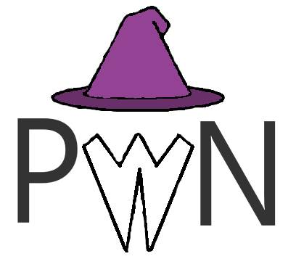

Colours:

I used Purple, Black and White

The purple is used because it matches with the logo’s hat and the magic theme and also as the child friendly color. The black is used for teens which pairs nice with the purple because even though purple is bright, it’s still a darker color making it good for children and teens. The white is to make everything more neutral for adults and older people, it also works with the beard in the logo.

Rough Site Plan:

Mobile: Desktop:

